भारतमौसमविज्ञानविभाग |  | India Meteorological Department
Sunday,15th June 2025 (25 Jyeshtha 1947 Saka)
Summary of observations recorded at 0830 hours IST: The Northern Limit of Monsoon continues to pass through 17.0°N/55°E, 17.5°N/60°E, 18°N/65°E, 18.5°N/70°E, Mumbai, Ahilyanagar, Adilabad, Bhawanipatna, Puri, Sandhead Island, 23.5°N/89.5°E, Balurghat, 30°N/85°E. Conditions are favourable for further advancement of Southwest monsoon over some parts of Gujarat, some more parts of Vidarbha, Chhattisgarh & Odisha during next 24 hours; over some parts of West Bengal, Jharkhand, Bihar and East Uttar Pradesh during subsequent 3 days. The cyclonic circulation over south Bangladesh & adjoining north Bay of Bengal lay over northwest Bay of Bengal & neighbourhood between 3.1 & 7.6 km above m. s. l. tilting southwestwards with height. The cyclonic circulation over westcentral Bay of Bengal off north coastal Andhra Pradesh coast at 5.8 km above m. s. l. merged with the cyclonic circulation over northwest Bay of Bengal & neighbourhood. The upper air cyclonic circulation over Marathwada lay over south Madhya Maharashtra & neighbourhood and extended upto 7.6 km above m. s. l. titling southwestwards with height. A trough ran from east Madhya Pradesh to Bangladesh across Chhattisgarh, Jharkhand & Gangetic West Bengal and extended upto 1.5 km above m. s. l. tilting southwestwards with height. The cyclonic circulation over central Assam & neighbourhood persisted at 4.5 km above m. s. l. The upper air cyclonic circulation over west Rajasthan & adjoining Pakistan lay over north Rajasthan & neighbourhood and extended upto 1.5 km above m. s. l. The trough from the upper air cyclonic circulation over west Rajasthan & adjoining Pakistan to north Madhya Maharashtra ran from the upper air cyclonic circulation over north Rajasthan & neighbourhood to west Madhya Pradesh at 1.5 km above m. s. l. An upper air cyclonic circulation lay over south Himachal Pradesh & adjoining north Uttarakhand at 1.5 km above m. s. l. An upper air cyclonic circulation lay over east Uttar Pradesh & neighbourhood at 0.9 km above m. s. l. The Western Disturbance as a trough in middle tropospheric westerlies with its axis at 5.8 km above m. s. l. ran roughly along Long. 70°E to the north of Lat. 26°N. persisted. The trough from the upper air cyclonic circulation over Marathwada & neighbourhood to coastal Andhra Pradesh became less marked. The trough from the cyclonic circulation over south Bangladesh & adjoining north Bay of Bengal to south Odisha became less marked.
Day temperatures were markedly above normal (> 5.1°C) at few places over Assam & Meghalaya; at isolated places over Sub Himalayan West Bengal & Sikkim, East Uttar Pradesh, West Uttar Pradesh, Himachal Pradesh, West Madhya Pradesh and East Madhya Pradesh. appreciably above normal (3.1°C to 5.0°C) at many places over Punjab; at most places over Bihar; at few places over Nagaland, Manipur, Mizoram & Tripura, Haryana-Chandigarh-Delhi and West Rajasthan; at isolated places over Gangetic West Bengal, Odisha, Jammu-Kashmir Ladakh-Gilgit-Baltistan-Muzaffarabad, East Rajasthan, Gujarat Region, Saurashtra & Kutch and Vidarbha. above normal (1.6°C to 3.0°C) at many places over Uttarakhand; at most places over Arunachal Pradesh; at isolated places over Chhattisgarh and Tamil Nadu, Puducherry & Karaikal. near normal (-1.5°C to 1.5°C) at many places over Konkan & Goa and Madhya Maharashtra; at most places over Jharkhand, Coastal Karnataka and Lakshadweep; at few places over Andaman & Nicobar Islands, Coastal Andhra Pradesh & Yanam, Telangana, Rayalaseema and Kerala & Mahe; at isolated places over North Interior Karnataka and South Interior Karnataka. The highest maximum temperature of 46.5°C was reported at Sriganganagar (Rajasthan).
The Southwest Monsoon has been active over Konkan & Goa, coastal Karnataka and Kerala. It has been subdued over Rayalaseema.
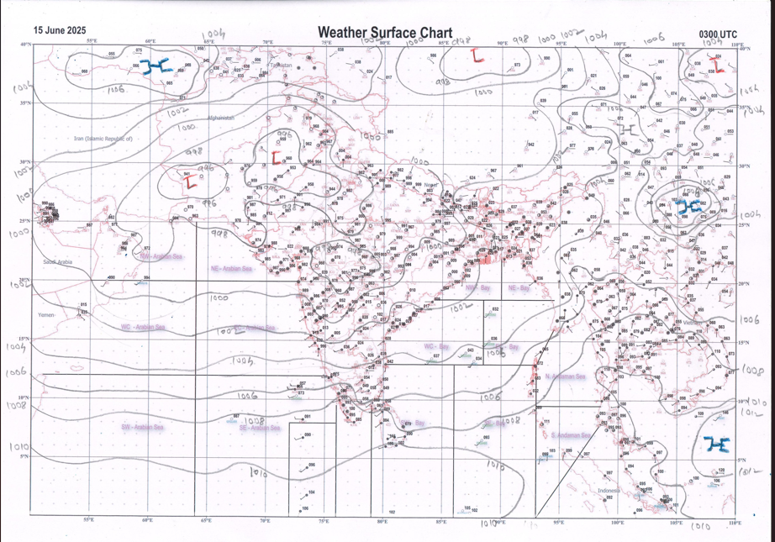 | 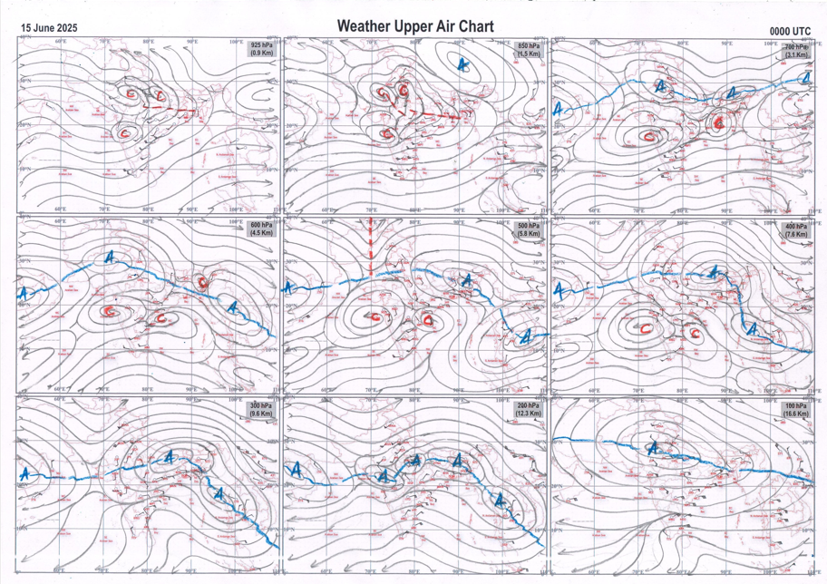
g.1. Analysed surface chart based on 03z observation | Fig.2. Analysed upper air chart based on 00z observation

Dr. Sudeep Kumar B.L.
Scientist ‘D’
CR & S Office, Pune  Issued at 1245 hrs. IST |  | Weather Forecasting Division  CR&S, Pune

Indian regions | Realised rainfall (chief amount in cm during past 24 hrs):
East | most places: Sub-Himalayan West Bengal & Sikkim#  many places: Nagaland-Manipur-Mizoram-Tripura+  a few places: Arunachal Pradesh and Assam & Meghalaya+  isolated places: Gangetic West Bengal+, Odisha+, Jharkhand◆ and Bihar++  Gurjongjhora tea estate & Washabari tea estate 20.6 each, Pothia 12.7, Amraghat 11.3, Lengpui 8.2, Sagar island PTO 7.7, Saiha & Daspalla 7.4 each, Silchar & Kolasib ARG 6.9 each, B p ghat 6.4, Kochadhaman 6.2, Kalimpong 5.6, Patnagarh 5.1, Paradeep cwr 2.1, Durgachack 1.7, Roing 1.3, Yazali 0.8, Diamond harbour 0.6, Forbesganj 0.2, Ziro & Latehar balumat kvk AWS 0.1 each.
North | isolated places: east Uttar Pradesh, west Uttar Pradesh+, Uttarakhand, Haryana, Punjab, Jammu-Kashmir and Ladakh◆, west Rajasthan and east Rajasthan+  dry weather: Himachal Pradesh  Gunnaur 8.1, Sagwara 7.2, Ankinghat & Kapkot 5.3 each, Bareilly CWC 5.0, Sama 4.8, Lodi road 4.4, Safdarjung 4.2, Shahabad 4.0, Lodi road AWS 3.7, Sandila 3.5, Nokha 3.3, Sangaria SR 2.5, Chittorgarh 1.9, Joshimath 1.8, Etawah & Sangrur 1.6 each, Prayagraj PBO 1.3, Nabha 0.6, Patiala 0.5, Ganganagar 0.4, Sonemarg dual AWS & Gulmarg RS 0.2 each, Larnoo ARG 0.1.
Central | many places: west Madhya Pradesh+  a few places: east Madhya Pradesh+ and Vidarbha  isolated places: Chhattisgarh  Umreth 8.1, Garhakota 6.8, Khandwa 6.7, Khirkiya-arg 5.5, Satwas 4.8, Dantewara 4.5, Amraoti 4.4, Chindwara-aws 4.2, Chikhalda 3.6, Paratwada 3.5, Bilaspur 2.8, Kondagaon 2.5.
Peninsula | most places: Konkan & Goa#, coastal Karnataka# and Kerala+++  many places: Gujarat Region+  a few places: Saurashtra & Kutch+, Madhya Maharashtra+, coastal Andhra Pradesh and south interior Karnataka++  isolated places: Marathwada, Telangana+, Rayalaseema, Tamil Nadu+++ and north interior Karnataka+  Mandangad 25.0, Panambur 20.5, Wakwali ARG 20.0, Mangaluru 16.9, Hosdurg 15.3, Kudulu 15.1, Kottigehara 14.7, Avalanche 14.3, Bantwal 14.2, Bhagamandala 13.1, Chinnakalar 12.8, Panjim 10.8, Kochi c.i.a.l. 10.6, Gondal 9.9, Venkatapur 8.7, Khambhat & Valparai PTO 7.8 each, Dasada 7.4, Kagaznagar 7.0, Gaganbawada 6.9, Rajkot & Shahuwadi 6.7 each, Londa & Agumbe emo 6.5 each, Soegaon & Veeraghattam 6.4 each, Mandal 6.2, Prathipadu 5.2, Tuni 4.7, Khanapur 4.4, Mahabaleshwar 4.1, Khultabad 3.5, Belagavi PTO 2.5, Dahod 2.4, Ramgundam 1.1, Tirupati AP 0.6, Chinnamandem & Cuddapah 0.4 each, Beed 0.2.
Islands | most places: Lakshadweep  many places: Andaman & Nicobar+  Maya bandar 6.8, Agathi 5.5, Minicoy 4.2, Amini 3.5, Long island 3.3, Port blair 0.7.
Table 2. Forecast / warnings (distribution of rain / thundershowers) for 7 days (valid from time of origin upto 0830 hrs IST of next day)
Sr. No |  | Sub-division Name | Day 1 | Day 2 | Day 3 | Day 4 | Day 5 | Day 6 | Day 7 | Sr. No. | Sub-division Name | Day 1 | Day 2 | Day 3 | Day 4 | Day 5 | Day 6 | Day 7
 |  |  | 15 Jun | 16 Jun | 17 Jun | 18 Jun | 19 Jun | 20 Jun | 21 Jun |  |  | 15 Jun | 16 Jun | 17 Jun | 18 Jun | 19 Jun | 20 Jun | 21 Jun
 | 1 | Andaman Nicobar Islands | F  | F | W | W | W | W | W | 19 | west Madhya Pradesh | F +  | F  | F  | F | W | W + | W +
 | 2 | Arunachal Pradesh | F +  | F +  | W++ | W++ | W++ | W ++ | F ++ | 20 | east Madhya Pradesh | F  | W +  | W +  | W +  | W ++  | W ++ | F
 | 3 | Assam-Meghalaya | F +  | W ++  | W ++  | W ++  | W ++  | W ++ | W ++ | 21 | Gujarat region | W ++  | W +  | F +  | F +  | S +  | F + | F +
 | 4 | Nagaland-Manipur-Mizoram-Tripura | F ++  | W ++  | W ++  | W ++  | W ++  | W ++ | W ++ | 22 | Saurashtra and Kutch | W++ | W++ | W++ | F +  | F +  | S | D
 | 5 | Sub Himalayan West Bengal/Sikkim | W++ | W + | F + | F + | F + | F | F | 23 | Konkan and Goa | W #  | W # | W ++ | W++ | W +  | W + | W +
 | 6 | Gangetic West Bengal | F+ | W+ | W++ | W+ | W+ | W + | W + | 24 | Madhya Maharashtra | S ++  | S ++ | S ++ | I + | I + | I + | I +
 | 7 | Odisha | F  | W++ | W++ | F ++  | F +  | S + | S | 25 | Marathwada | I  | I | I | I | I | I | I
 | 8 | Jharkhand | F  | F + | W++ | W ++ | W + | W+ | F | 26 | Vidarbha | I  | S+ | F + | F  | F  | W + | W
 | 9 | Bihar | S + | S + | F+ | F++ | F++ | W+ | W + | 27 | Chhattisgarh | S  | F++ | F ++ | F + | F +  | F | S
 | 10 | east Uttar Pradesh | I+ | S  | F  | F+ | W+ | W+ | F + | 28 | Coastal Andhra Pradesh and Yanam | S +  | S +  | S  | I  | I  | I | I
 | 11 | west Uttar Pradesh | S+ | S  | S  | S + | F+ | W+ | F + | 29 | Telangana | F +  | S  | I  | I  | I  | I | I
 | 12 | Uttarakhand | F + | W++ | W++ | W++ | W++ | W++ | W++ | 30 | Rayalaseema | S  | I  | I  | I  | I  | I | I
 | 13 | Haryana,Chandigarh and Delhi | S + | S  | I  | S  | F  | F | F + | 31 | Tamil Nadu, Puducherry and Karaikal | S #  | S++ | S +  | I | I | I | I
 | 14 | Punjab | I | S  | I  | I  | S  | S | S  | 32 | Coastal Karnataka | W #  | W # | W ++ | W + | W  | W | W
 | 15 | Himachal Pradesh | S  | S  | S  | S  | S  | F + | F + | 33 | North interior Karnataka | W ++ | W + | F + | F | S | S | S
 | 16 | Jammu-Kashmir and Ladakh | S  | S  | I  | I  | I  | I | I  | 34 | South interior Karnataka | W ++ | W ++ | F ++ | F | S | S | S
 | 17 | west Rajasthan | S  | S + | I  | I  | I  | I  | I  | 35 | Kerala and Mahe | W # | W++ | W++ | W+ | W +  | F | F
 | 18 | east Rajasthan | S +  | S + | I  | I  | I  | S+ | F + | 36 | Lakshadweep | W +  | W  | W  | W  | F  | F | F
Legends: D = Dry I = Isolated S = Scattered F = Fairly widespread W = Widespread #= heavy to very heavy rain at a few places with extremely heavy rain at isolated places +++= heavy rain at a few places with very heavy rain at Isolated places ++= heavy to very heavy rainfall @=Isolated exceptionally heavy rainfall + = heavy rain ●/*= rain or snow ♦ = very light rain ≡=fog= thunderstorm with lightning =Squall / Gusty / gale / strong wind ­ =cold wave/cold day += heat wave/warm night/hot and humid weathe r=Duststorm =ground frost = Hail

Fig. 4: Districtwise warnings for five days for Maharashtra State
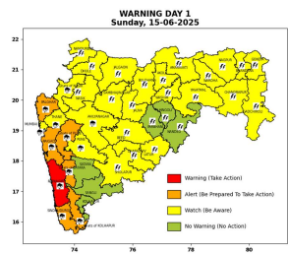 | 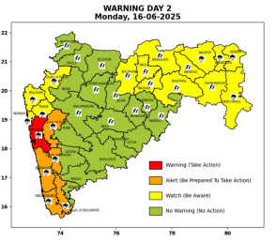 | 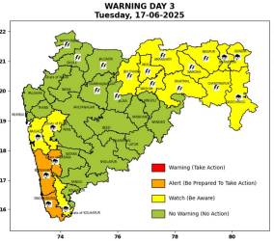 | 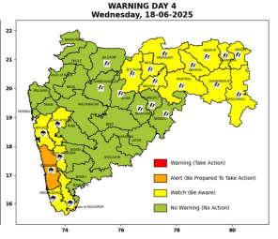 | 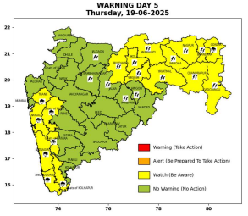

Pune, Lohegaon and Pashan observations at 0830 hrs. IST of Today
 | Temperature (°C) |  |  |  |  | Humidity (%) |  |  |  | Rainfall (mm)
 | Max.  past  24 hrs | Dep.  from  normal | Min.  past  24 hrs. | Dep.  from  normal | Dry  Bulb | At 0830 hrs. IST | Dep.  From  normal | At 1730  hrs. IST of y’day | Dep.  from  normal | Past  24 hrs. | Since  1st June | Dep.  from  normal
PNE | 32.4 | 0.0 | 24.7 | 1.8 | 26.0 | 89 | 10 | 65 | -1 | 0.3 | 132.9 | 53.8
PSN | 31.0 | - | - | - | - | - | - | 74 | - | - | 137.7 | -
LHG | 33.9 | 0.9 | 26.1 | 5.1 | 27.5 | 77 | 1 | 49 | -10 | 0.0+ | 138.8 | 88.5

 |  |  |  |  |  |  | Local (Pune and neighbourhood) forecast
Max./Min. Temperature (°C) |  |  |  |  |  |  |  |  | Weather
Date | Pune | Pashan | Lohegaon | Chinchwad | Lavale | Magarpatta | NDA | Koregoan Park
15/06/25 | 30/22.4* | 30/-- | 32/25.4* | 29/23.6* | 29/23.1* | 30/24.9* | 29/24.4* | 30/25.9* | Generally cloudy sky. Thunderstorm with lightning, light to moderate rain very likely.
16/06/25 | 32/24 | 31/23 | 33/25 | 31/24 | 30/23 | 32/25 | 32/23 | 33/25 | Generally cloudy sky. Light to moderate rain very likely.
17/06/25 | 33/24 | 32/23 | 33/25 | 32/24 | 31/23 | 32/25 | 32/23 | 33/25 | Generally cloudy sky. Light to moderate rain very likely.
18/06/25 | 33/23 | 32/22 | 33/24 | 32/23 | 31/22 | 33/24 | 33/22 | 33/24 | Partly cloudy sky becoming generally cloudy sky towards afternoon or evening. Light rain very likely.
19/06/25 | 34/23 | 33/22 | 34/24 | 33/23 | 32/22 | 33/24 | 33/22 | 34/24 | Partly cloudy sky becoming generally cloudy sky towards afternoon or evening. Light rain likely.
20/06/25 | 34/23 | 33/22 | 34/24 | 33/23 | 32/22 | 34/24 | 34/22 | 34/24 | Partly cloudy sky becoming generally cloudy sky towards afternoon or evening. Light rain likely.
21/06/25 | 34/23 | 33/22 | 34/24 | 33/23 | 32/22 | 34/24 | 34/22 | 34/24 | Partly cloudy sky becoming generally cloudy sky towards afternoon or evening. Light rain likely.
Rainfall Distribution |  |  | Rainfall Categories | Rainfall (mm) |  | Cloud condition |  |  |  | Rainfall Intensity |  | Range
Widespread (W) | 76-100% |  | Very Light rain | Trace to 2.4 mm |  | Mainly clear sky |  | 1-2 oktas |  | Light Spell |  | 1 cm/hr
 |  |  | Light rain | 2.5 to 15.5 mm |  | Partly cloudy sky |  | 3-4 oktas |  | Moderate Spell |  | 1-2 cm/hr
Fairly Widespread (FW) | 51 – 75% |  | Moderate rain | 15.6 to 64.4 mm |  | Generally cloudy sky |  | 5-7 oktas |  | Intense Spell |  | 2-3 cm/hr
Scattered (S) | 26 – 50% |  | Heavy rain | 64.5 to 115.5 mm |  | Overcast |  | 8 oktas |  | Very Intense Spell |  | 3-5 cm/hr
isolated (I) | 1 – 25% |  | Very heavy rain | 115.6 to 204.4 mm |  |  |  |  |  | Extremely Intense Spell |  | 5-10 cm/hr
D (D) | No Rain |  | Extremely heavy rain | ≥ 204.5 mm |  |  |  |  |  | Cloudburst |  | > 10 cm/hr
Probability Terms in %: |  |  | Heavy snow | 6.5 to 11.5 cms water equivalent of rain
unlikely | < 25 |  | Very heavy snow | 11.6 to 20.4 cms water equivalent of rain
likely | between 25 50
very likely | between 51 75
most likely | >75
* = realized temperature
Mumbai (Colaba) |  |  |  | Nagpur (AP)
Date 2025 | T max °C | T min °C | Weather | T max °C | T min °C | Weather
15/06 | 31 | 25 | Generally cloudy sky with Heavy rain. | 39 | 27 | Rain or thundershowers accompanied with lightning & gusty winds(40-50kmph).
16/06 | 31 | 24 | Generally cloudy sky with Heavy rain. | 38 | 27 | Rain or thundershowers accompanied with lightning & gusty winds(40-50kmph).
17/06 | 32 | 24 | Generally cloudy sky with intermittent rain. | 38 | 26 | Heavy rain or thundershowers accompanied with lightning
18/06 | 32 | 24 | Generally cloudy sky with intermittent rain. | 37 | 26 | Heavy rain or thundershowers accompanied with lightning
19/06 | 32 | 24 | Generally cloudy sky with intermittent rain. | 37 | 26 | Heavy rain or thundershowers accompanied with lightning
20/06 | 32 | 24 | Rain. | 36 | 25 | Heavy rain or thundershowers accompanied with lightning
21/06 | 32 | 24 | Rain. | 36 | 25 | Heavy rain or thundershowers accompanied with lightning

